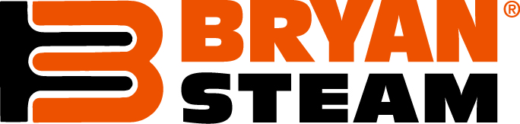
Bryan Boiler 2014 End of Year Update
I. Plant Holiday Operating Schedule
Bryan Boiler will be closed on December 24, 25, 31 and Jan 1st of 2015. Also, as has been the practice for the last several years, Bryan Boiler’s manufacturing operation will not be working from December 24-January 2. This means that we will not be shipping any items out except Emergency Parts orders.
2. 2015 Price Increase
As mentioned in the previous update, Bryan will be instituting a price increase between 2-4% after the first of the year. We planned to have that start on January 1st but we wanted to expand several of the pricing sections and those changes have pushed the pricelist launch back about 2-3 weeks. With that information in mind; we will now make the pricelist effective date February 1st.
3. 2015 AHR Trade Show
As mentioned previously, Bryan Boiler will be displaying for the 29th consecutive year at the AHR Trade Show in Chicago on 1/26 – 1/28. Our booth number will be 4257 and we are planning to bring a significant number of Bryan employees to participate in and around our booth. We are anxious to see all of you at the show and have also several activities surrounding the show that will help us interact with all of you in a more relaxed surrounding. The main two informal events that are scheduled will be the First Annual Bryan Whirlyball Extravaganza and the Burnham Holdings AHR party.
Whirlyball is a cross between jai alai/basketball and bumper cars. We have reserved a facility for a private event from 1-3 on Sunday (1/25). We have roughly 20 spots to fill and would love to have all of you join us in this fun event. This will be a fun high energy event that will show a different side of all those that choose to play. Please shoot me an email if you and/or members of your team are interested in playing.
The Burnham Holdings AHR party will be held at the Vertigo Sky Lounge on Sunday the 25th from 5-8. You will need to RSVP with the enclosed document (attached below). This event will have the entire Bryan management team as well as executives from our parent company as well.
4. 2015 Sales Meeting
We are very excited to get back to Las Vegas for our annual sales meeting. The meeting this year will be held at the Vdara Hotel & Resort. We will start on Monday 3/30, finishing with golf on Wednesday afternoon. We will be sending out a registration link in the very near future, to allow you to register for the meeting.
5. Happy Holidays from the Bryan Boiler Team
Finally, we at Bryan wish you and your families a wonderful Holiday Season and very happy and prosperous 2015.

Best Regards,
David C. Allen
David Allen
Bryan Boiler National Sales Manager

